Newport’s Eureka Cemetery still trying stop their landslide from worsening March 28, 2011

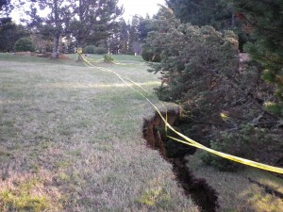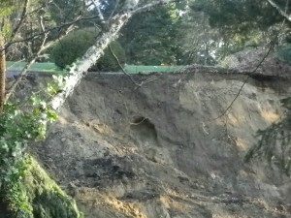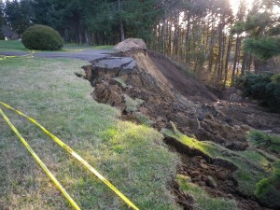Eureka Cemetery Slide, Yaquina Heights Drive
Newport’s Eureka Cemetery is still trying to figure out how to repair a large slide that hit their burial area south of Yaquina Heights Drive. Cemetery Manager Gary Wenell said it was in mid-January, after a sustained downpour over a 36 hour period, a large slide gave way and destroyed an access road and the better part of an acre of land. Wenell said the top edge of the slide is barely thirty feet from the nearest grave.
Wenell said preliminary cost estimates from local contractors put a permanent fix at around $150,000, an amount that exceeds their non-profit capabilities. So they are having to get creative. Wenell said they are installing a french drain to divert storm water around the lower burial area so the ground water doesn’t keep aggravating the slide. He said they are also interested in exploring one option that would entail having a contractor just do the “toe” work necessary to stop the bottom of the slide and then put a call out to all contractors in the region that Eureka Cemetery needs “fill dirt.” He said he’s been told that it would not take long to fill it in with the amount of surplus dirt that contractors have to dispose of over the period of a year or two.
Wenell said he and his board of directors are interested in any ideas about a fix that doesn’t cost a lot of money. Wenell can be reached at 541-961-3339, and his e-mail is EurekaCemetery@Charter.Net.

